High power ZBL test

λ = 1550 nm

Plaser = 5 W

Coil diameter = 25 mm

Transmission to ZBL fibre (A) = 96.4%

Length of ZBL test fibre = 5 m ± 10 cm

Back scattered power = 1 ± 0.1 μW, Dominated by reflections from FC/APC connector. No deviation from linear with P.

After operation at 5 W for 3 hours, coil reached thermal equilibrium at ~26° C.

Transmitted power (B) as a function of Pin (A):

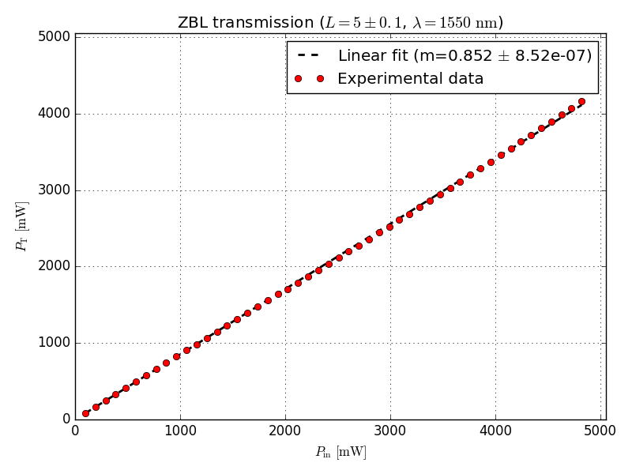

Setup:

